# FAROOK COLLEGE

## (AUTONOMOUS)

KOZHIKODE



BACHELOR OF VOCATION (B.Voc.) PROGRAMME

IN

(SOFTWARE DEVELOPMENT)

2020 – 2023

2nd SEMESTER

PROJECT REPORT

TEAM – F

Name of the studetns

# FAROOK COLLEGE

## (AUTONOMOUS)

KOZHIKODE



BACHELOR OF VOCATION (B.Voc.) PROGRAMME

IN

(SOFTWARE DEVELOPMENT)

2020 – 2023

4th SEMESTER

PROJECT REPORT

ON

“CREATIVE SCRAPYARD”

|  |  |  |  |
| --- | --- | --- | --- |
| NAME | : |  |  |
| CLASS NO. REGISTER NO. | : 01  : FKAUBVW001 | BATCH | : 2020-23 |

Certified Bonafide Laboratory Record of 4th semester Project during the year 2021-22 Submitted for Project viva held in… and valued.

Dated: ..................

Examiner 1)

2) Professor /Lecturer in charge

### DECLARATION

I, Abdul Ahad hereby declare that this Project report entitled “Creative Scrapyard” submitted to Farook College (Autonomous) in partial fulfilment of the requirements for the award of degree of Bachelor of Vocation in Software Development under the faculty of B.Voc is a bonafide record of work done by me under the guidance of mr. UMARSABIK U.K Assistant Professor, B.Voc. Software Development, Farook College (Autonomous), Kozhikode – 673 632.

I also declare that this report has not been submitted anywhere else for the award of any degree, diploma, associate ship, fellowship or other academic recognition.

Farook College

05.08.2022 ABDUL AHAD

### ACKNOWLEDGEMENT

I take this opportunity to express my sincere thanks and deep gratitude to all those people who extended their wholehearted co-operation and helped us in completing this project successfully.

I sincerely express my special thanks to Farook College.

I am pleased to thank the principal of Farook College Dr. K M Naseer, Our HOD Ms. Mubeena Mam, deep sense of gratitude to Ms. Rini Fernandez and Mr. Umarsabik U.K for showing their keen and personal interest in our work, and other faculty member for giving us wonderful opportunity to work on the project. This project helps to know more about existing features of HTML, CSS, MongoDB, and JAVASCRIPT. Project has provided a platform to implement things we have learnt and also learn more things in detail, which shall help me in future.

I would also like to thank all my colleagues, friends and classmates for helping me directly or indirectly throughout the project.

ABDUL AHAD

### TABLE OF CONTENT

|  |  |
| --- | --- |
| CONTENT | PAGE NO. |
| Abstract | 6 |
| Scope | 7 |
| Limitations | 7 |
| Features | 7 |
| Milestone | 8 |
| Introduction to PHP,CSS,MYSQL,JAVASCRIPT  And HTML | 9 |
| Design ( figure 1,2) | 11 |
| figure 3,4 | 12 |
| figure 5,6 | 13 |
| figure 7,8 | 14 |
| figure 9,10 | 15 |
| figure 13,14 | 18 |
| Conclusion | 16 |
| Reference | 16 |

ABSTRACT

Creative scrapyard is an ecommerce website that aims to be a platform where people can sell their old or scrap items. From our website an artist can buy those scrap items and customize the scrap items to make useful and decorative items. These creative items can be sold on the website itself and other people can buy these items. It helps people by selling their scrap, it helps the artists to buy stuffs on cheap rate and earn money by showing their creativity on it and it will also make the place a better place by recycling old items.

### INSPIRED FROM

* OLX
* Marketplace feature of Amazon

### INTRODUCTION

Creative Scrapyard is an ecommerce platform for users to buy/sell scrap or customized goods. Users can be service provider as well by selling their goods and clients by purchasing from our store. Admin manages the products and users.

### SELLER

Users can sell their products on our creative or scrap store by registering themselves with personal data’s like: ‘name, phone number, email’ and adding their products.

### BUYER

Users can buy from our creative or scrap store by registering themselves with personal data’s like: ‘name, phone number, email’ and ordering the product of their wish. Payment options we provide are cash on delivery or online payment. Products gets shipped to the buyer by the seller to the shipment address provided by the buyer in time of ordering.

### Admin

Admin is the owner/owners of this platform they have whole privilege in this platform. Admin can manage products and users. Admin has access to the whole products to edit or delete as well as manage users by denying access to their accounts who violates rules.

### SCOPE

* Bring both sellers and buyers in one place
* Buyers have wide choice
* Buyers get to purchase with multiple payment method
* Ensure buyer–seller trust

### LIMITATIONS

* Not location based
* No search bar feature
* No filter feature
* Only used default security features of Express
* Code not in standard

### FEATURES

* Buy creative products
* Sell scrap products
* Online payment

### MILESTONE

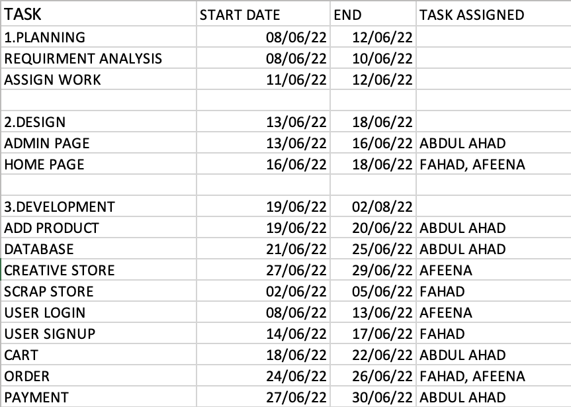

USED STACKS

* HTML
* CSS
* JAVASCRIPT
* BOOTSTRAP
* EXPRESS
* MONGODB
* HEROKU

### HTML

The HyperText Markup Language, or HTML is the standard markup language for documents designed to be displayed in a web browser. It can be assisted by technologies such as Cascading Style Sheets and scripting languages such as JavaScript.

### CSS

Cascading Style Sheets (**CSS**) is a stylesheet language used to describe the presentation of a document written in HTML or XML (including XML dialects such as SVG, MathML or XHTML).CSS describes how elements should be rendered on screen, on paper, in speech, or on other media. **CSS** is among the core languages of the open web and is standardized across Web browsers according to W3C specifications.

### JAVASCRIPT

JavaScript, often abbreviated JS, is a programming language that is one of the core technologies of the World Wide Web, alongside HTML and CSS. Over 97% of websites use JavaScript on the client side for web page behavior, often incorporating third-party libraries.

### BOOTSTRAP

**Bootstrap is** a free and open-source web development framework. It's designed to ease the web development process of responsive, mobile-first websites by providing a collection of syntax for template designs. In other words, **Bootstrap** helps web developers build websites faster as they don't need to worry about basic commands and functions.

### EXPRESS

**Express is** a minimal and flexible Node.js web application framework that provides a robust set of features to develop web applications and mobile applications. It facilitates the rapid development of Node based web application.

### MongoDB

MongoDB is a source-available cross-platform document-oriented database program. Classified as a NoSQL database program. MongoDB uses JSON-like documents with operational schemas.

### HEROKU

Heroku is a cloud platform as a service supporting several programming languages. One of the first cloud platforms, Heroku has been in development since June 2007, when it supported only the Ruby programming language, but now supports Java, Node.js, Scala, Clojure, Python, PHP, and Go.

DESIGN



Figure 1: Home page cover and navigation

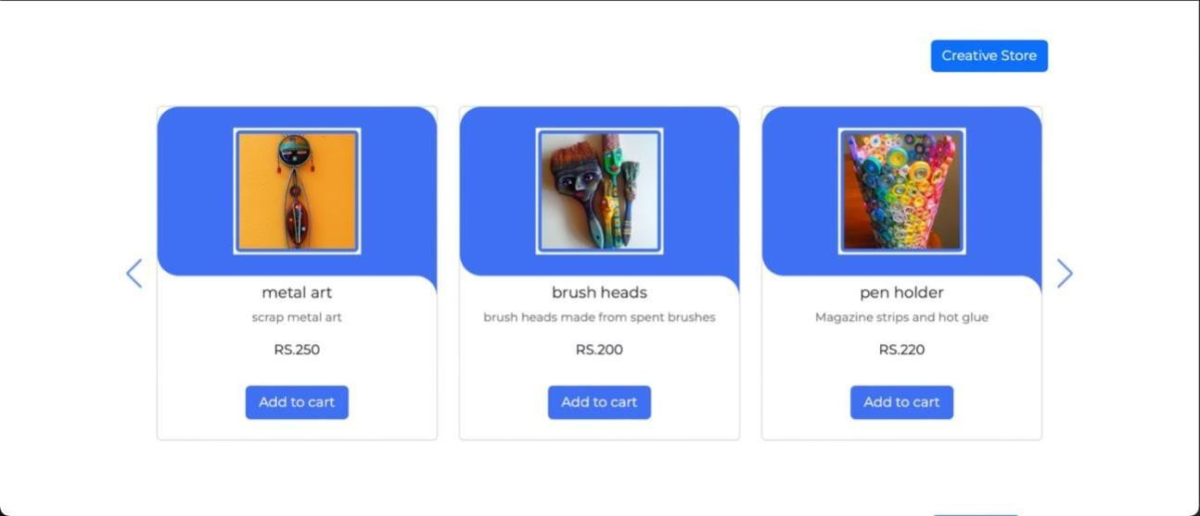

Figure 2: Creative store list in home page

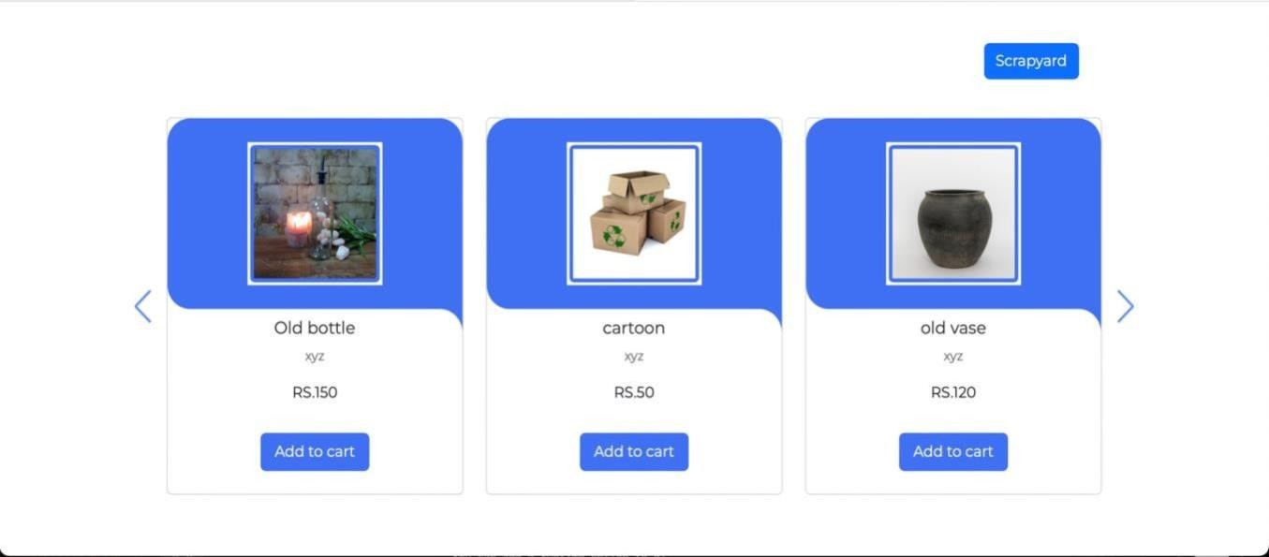

Figure 3: Scrapyard store list in home page

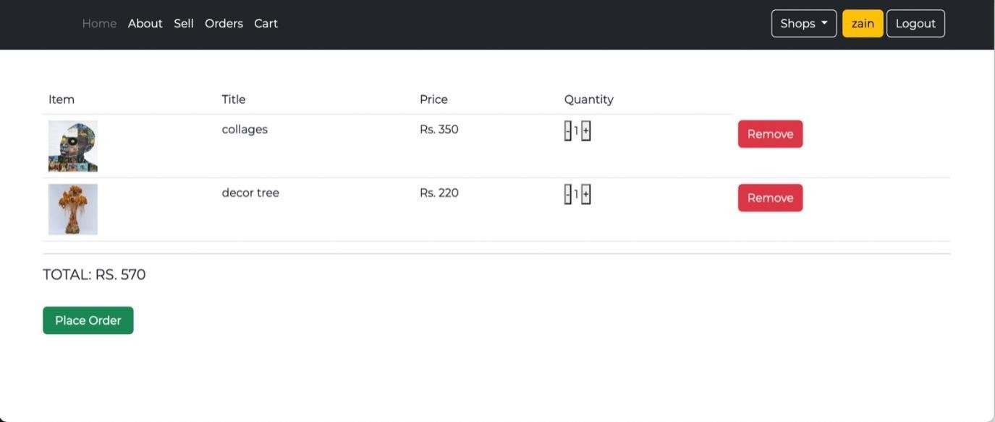

Figure 4: Cart page

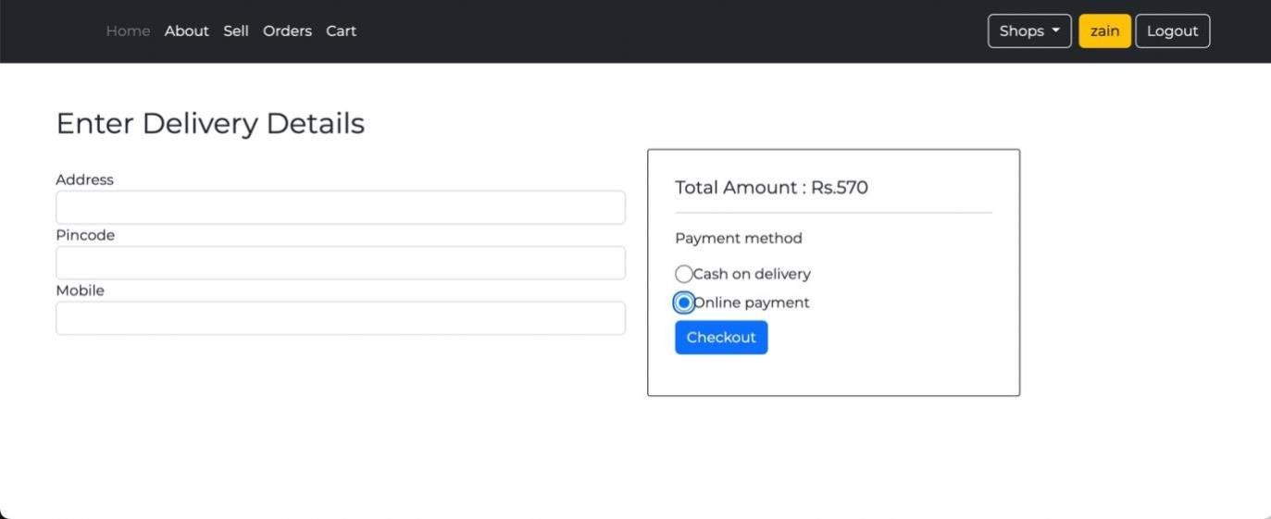

Figure 5: Order page

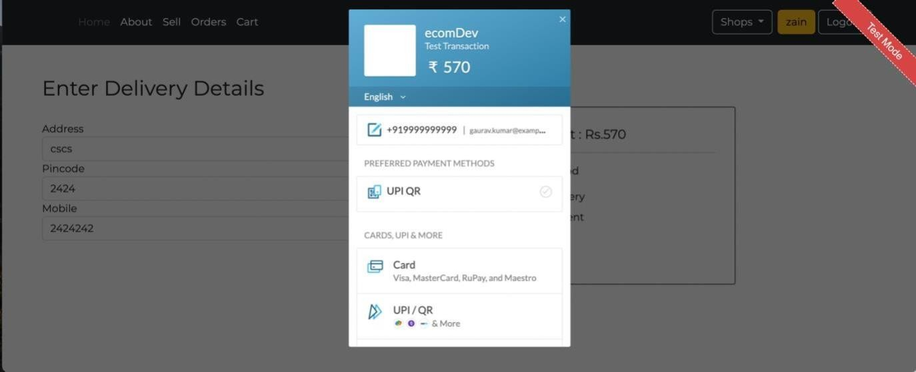

Figure 6: Payment page

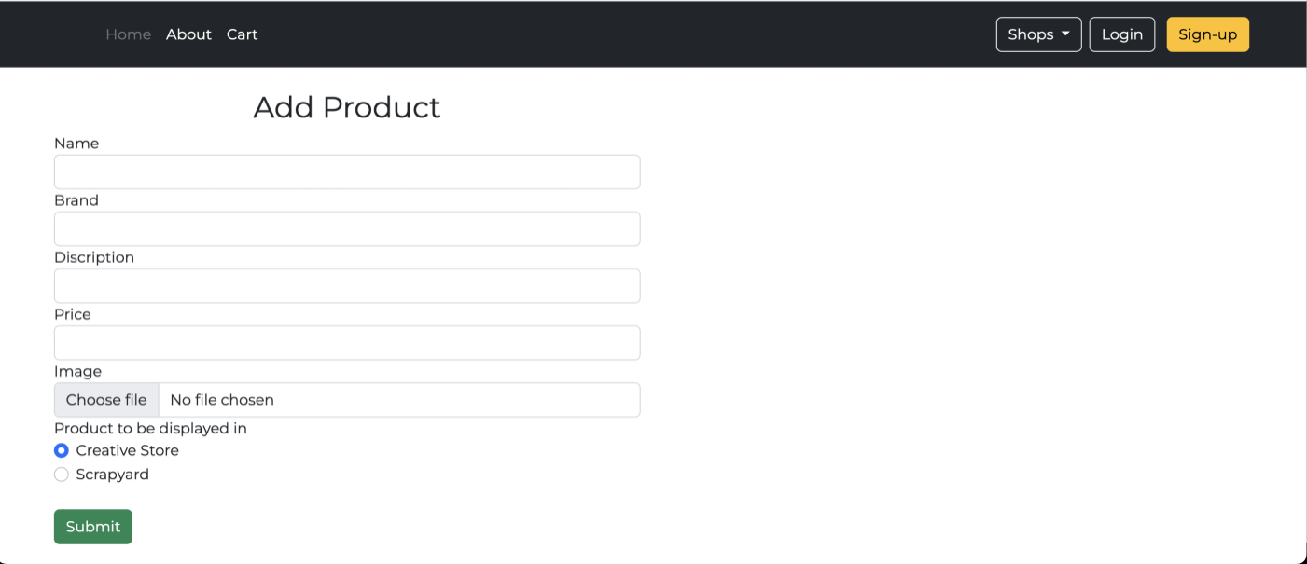

Figure 7: Add product page

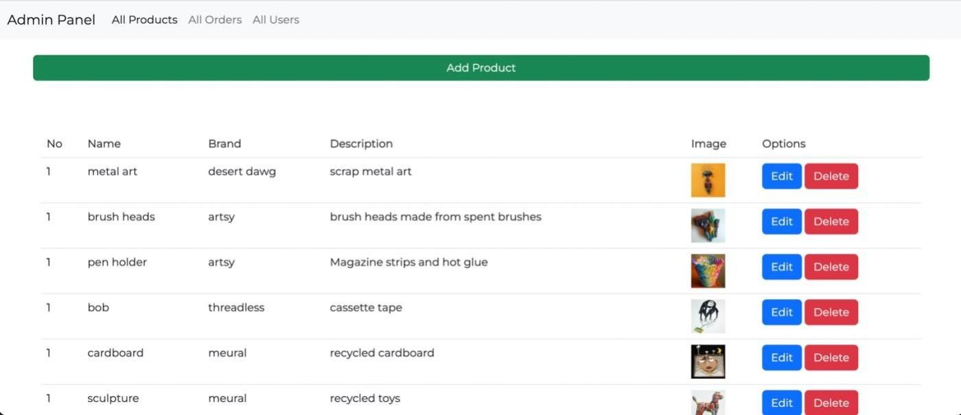

Figure 8: All product list

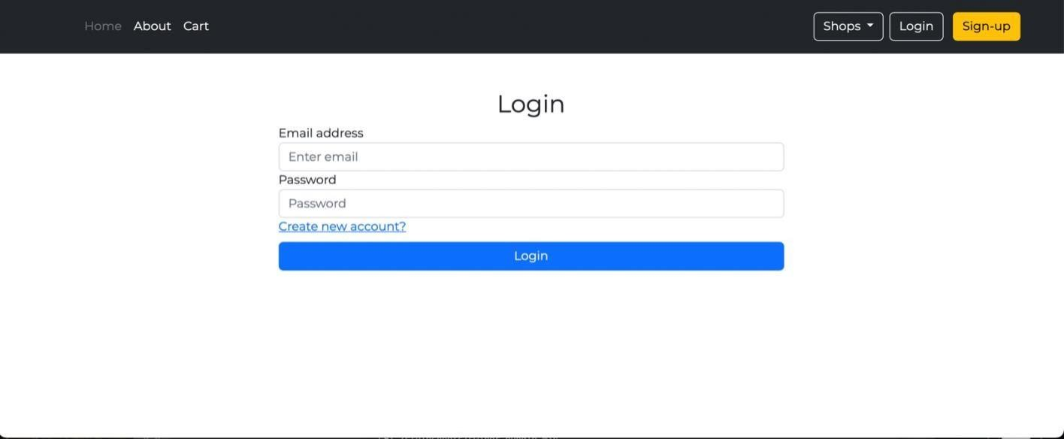

Figure 9: User login page

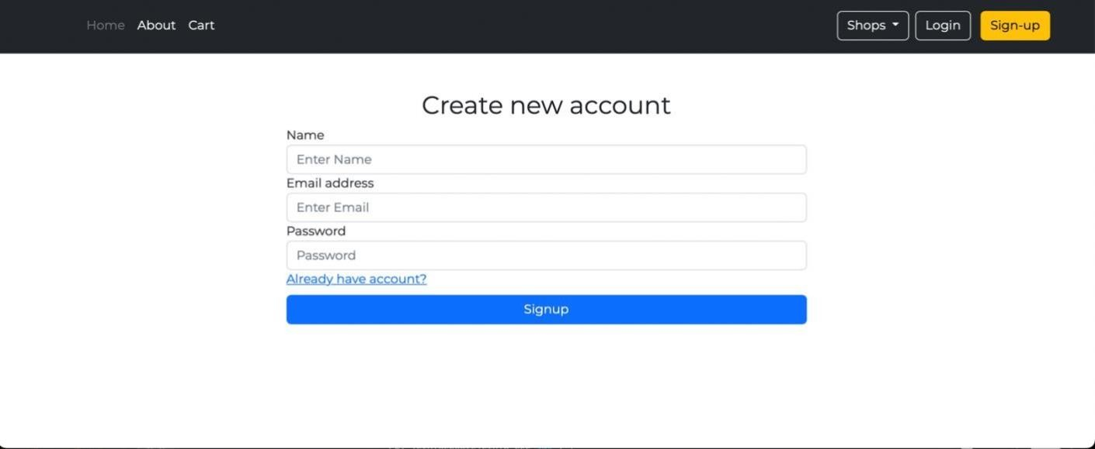

Figure 10: User signup page

### CONCLUTION

We concluding our project report on ‘Creative Scrapyard’ that we developed a web- app platform with Express(frame work from Node.js) to buy and sell scrap or customized products. We gain experiences a lot by designing, building through contributions, testing and deploying our project ‘Creative Scrapyard’

## REFERENCE

* [https://www.djangoproject.com](https://www.djangoproject.com/)
* [https://www.w3schools.com](https://www.w3schools.com/)
* [https://getbootstrap.com](https://getbootstrap.com/)
* [https://www.heroku.com](https://www.heroku.com/)
* [https://stackoverflow.com](https://stackoverflow.com/)
* [https://www.geeksforgeeks.org](https://www.geeksforgeeks.org/)
* [https://www.wikipedia.org](https://www.wikipedia.org/)